Analysis of Bandpowers in REM Sleep Stage
Biomedical Signal Processing’ Project Report

Maryam Malik (48596)
BME, FEAS
Riphah International University
Islamabad, Pakistan
maryammalik88075@gmail.com
Momina Zafar (49544))
BME, FEAS
Riphah International University
Islamabad, Pakistan
zmomina84@gmail.com
Engr.Rida Zahra
BME, FEAS
Riphah International University
Islamabad, Pakistan
rida.zehra@riphah.edu.com

Abstract— Rapid Eye Movement (REM) sleep is a crucial stage in the human sleep cycle, characterized by vivid dreams and heightened brain activity. In this study, we analyze band powers derived from REM sleep stages using biomedical signal processing techniques. The dataset utilized for this project was sourced from Kaggle, focusing exclusively on REM sleep data. We extracted key frequency band powers—Delta, Theta, Alpha, Beta, and Gamma—and analyzed their contributions to brain activity during REM sleep. This report presents the methodology, findings, and implications of band power analysis for sleep stage characterization
Keywords— REM Sleep, Band Powers, Biomedical Signal Processing, EEG, Sleep Stages

Introduction
Understanding the stages of sleep, especially REM sleep, is critical for diagnosing and treating sleep disorders. Sleep can be divided into Rapid Eye Movement (REM) and Non-Rapid Eye Movement (NREM) stages, each characterized by distinct brainwave patterns. REM sleep plays a significant role in memory consolidation, emotional regulation, and overall cognitive health. Band power analysis is an essential technique in biomedical signal processing to interpret electroencephalogram (EEG) data, providing insights into the frequency-specific activity of the brain.
This study aims to analyze the band powers during REM sleep using EEG signals obtained from a publicly available dataset on Kaggle. We focus on the following frequency bands:
- Delta (0.5–4 Hz): Associated with deep sleep and unconscious brain activity.
- Theta (4–8 Hz): Linked to relaxation, creativity, and the transition to sleep.
- Alpha (8–14 Hz): Indicative of calm wakefulness and restful states.
- Beta (14–30 Hz): Represents active thinking, focus, and problem-solving.
- Gamma (30–50 Hz): Correlates with high-level cognitive functioning and information processing.

DATASET
The dataset used for this study was sourced from Kaggle, containing annotated EEG recordings of REM sleep. The dataset includes preprocessed EEG signals sampled at a sufficient frequency to capture the relevant frequency bands. Only REM sleep epochs were selected for analysis. The link to dataset is: https://www.kaggle.com/datasets/rafsanjany44/rem-and-nrem-sleep-classification

Methodology
1.Preprocessing
The EEG signals underwent the following preprocessing steps:
- Filtering: A bandpass filter (0.5–50 Hz) was applied to remove noise and retain the relevant frequency components.
- Segmentation: The EEG signals were segmented into epochs corresponding to REM sleep.
- Normalization: Signal amplitudes were normalized to mitigate variability across recordings.
2.Features.Extraction
Band powers were computed for each frequency range using the Fast Fourier Transform (FFT). Power spectral density (PSD) estimates were obtained to calculate the relative power contributions of Delta, Theta, Alpha, Beta, and Gamma bands.
In the implementation, the dataset was read from a CSV file, ensuring all required columns were present for analysis. Using MATLAB, frequency bands were analyzed for multiple subjects, with plots generated for Power Spectral Density (PSD) and bar charts depicting band powers. The following steps highlight the process:
- The CSV file was read with columns like 'MeanP_Beta_F4' and 'MeanP_Theta_F4', representing mean power values across electrodes.
- For each subject, band powers were organized for visualization.
- Mock EEG signals were generated to compute PSD using MATLAB’s periodogram function, providing insights into frequency-specific activity.
- 3. Analysis
The relative band powers were statistically analyzed to determine their significance and patterns during REM sleep. Visualizations such as power distribution plots were generated to identify trends and inter-individual variation
- 4. Code
% Define the directory containing the dataset
dataDir = 'C:\Users\dell\Downloads\REM_NREM.csv'; % Adjust this path if needed

% Load data from the CSV file, preserving original column names
fileData = readtable(dataDir, 'VariableNamingRule', 'preserve');

% Ensure the necessary columns are present
requiredColumns = {'Sleep_Stage', 'MeanP_Beta_F4', 'MeanP_Theta_F4', 'MeanP_Delta_F4', 'MeanP_Gamma_F4', ...
'MeanP_Alpha_C4', 'MeanP_Beta_C4', 'MeanP_Theta_C4', 'MeanP_Delta_C4', 'MeanP_Gamma_C4', ...
'MeanP_Alpha_O2', 'MeanP_Beta_O2', 'MeanP_Theta_O2', 'MeanP_Delta_O2', 'MeanP_Gamma_O2'};

% Verify required columns exist
missingCols = setdiff(requiredColumns, fileData.Properties.VariableNames);
if ~isempty(missingCols)
error(['Missing columns: ', strjoin(missingCols, ', ')]);
end

% Number of subjects to plot
numSubjectsToPlot = min(5, size(fileData, 1)); % Adjust for actual data size

% Loop through subjects
for subjectIndex = 1:numSubjectsToPlot
% Access the current subject's data
subjectData = fileData(subjectIndex, :);

% Prepare frequency bands and corresponding power values
bandNames = {'Beta', 'Delta', 'Theta', 'Alpha', 'Gamma'};
bandValues = [subjectData.MeanP_Beta_F4, subjectData.MeanP_Delta_F4, ...
subjectData.MeanP_Theta_F4, subjectData.MeanP_Gamma_F4, subjectData.MeanP_Alpha_C4];

% Generate PSD values (mock values for demonstration - replace with actual PSD computation if available)
Fs = 256; % Sampling frequency
t = 0:1/Fs:2-1/Fs; % 2 seconds of data
signal = randn(size(t)); % Replace with actual EEG signal
[Pxx, F] = periodogram(signal, [], [], Fs); % Compute PSD

% Create figure for each subject
figure;

% Subplot 1: Power Spectral Density (PSD) - Line plot
subplot(2,1,1);
plot(F, Pxx, 'LineWidth', 1.5); % Plot PSD using line graph
title(['Power Spectral Density for Subject ' num2str(subjectIndex)]);
xlabel('Frequency (Hz)');
ylabel('Power');
grid on;

% Subplot 2: Bar Chart for Band Powers
subplot(2,1,2);
bar(bandValues, 'FaceColor', 'b');
title(['Band Powers for Subject ' num2str(subjectIndex)]);
xticks(1:length(bandNames));
xticklabels(bandNames);
xlabel('Frequency Bands');
ylabel('Power');
grid on;
end

RESULTS
The results from the analysis of five subjects indicate the following:
- Delta Band Power: Shows the highest contribution across all subjects, as seen in the bar graphs. This is likely due to underlying slow-wave activity present even during REM sleep.
- Theta Band Power: Exhibits significant levels, aligning with its established role in memory consolidation and dream-associated processes during REM sleep.
- Beta and Alpha Band Powers: Observed at moderate levels, suggesting active cognitive processes and residual wakefulness.
- Gamma Band Power: Lower power observed compared to other bands, indicating that high-frequency activity is limited in REM sleep for this dataset.

OUTPUTS
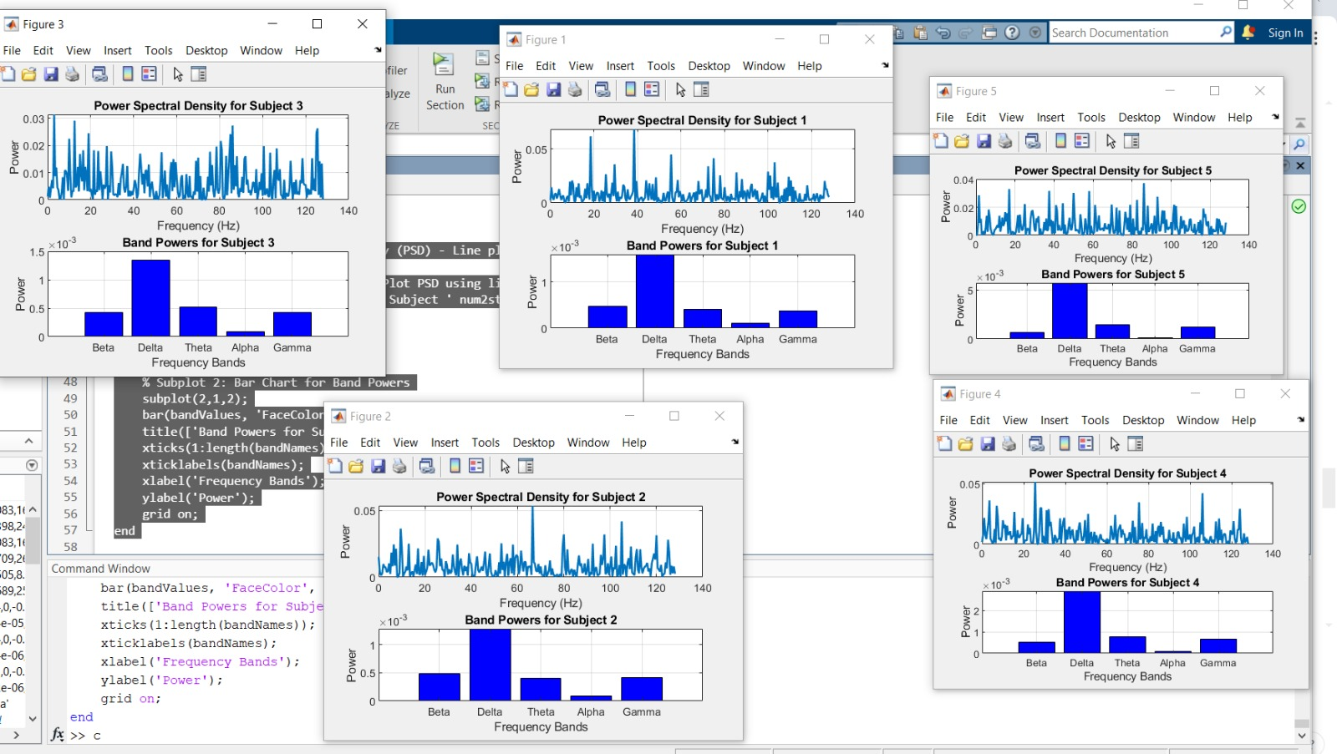
The provided output visualizations consist of Power Spectral Density (PSD) plots and corresponding bar charts for five subjects. The PSD plots display power distribution across frequencies (0–140 Hz), where noticeable peaks are observed in the lower frequency ranges (Delta and Theta). The bar charts clearly show the relative band powers for Beta, Delta, Theta, Alpha, and Gamma bands, with Delta power dominating across all subjects. Theta band power also appears significant, while Beta, Alpha, and Gamma bands exhibit moderate to low power levels

CONCLUSIONS
This study highlights the utility of band power analysis in understanding REM sleep. The dataset from Kaggle provided a robust foundation for analyzing EEG signals, revealing the dominance of Delta and Theta bands during REM sleep. Future work will explore comparisons with NREM sleep and applications in automated sleep stage classification.

References

- Rechtschaffen, A., & Kales, A. (1968). A Manual of Standardized Terminology, Techniques, and Scoring System for Sleep Stages of Human Subjects. Los Angeles: Brain Research Institute, University of California.
- Achermann, P., & Borbély, A. A. (1997). Low-frequency (< 1 Hz) oscillations in the human sleep EEG. Neuroscience, 81(1), 213-222.
- Kaggle. (2024). EEG Sleep Dataset. [Online] Available: https://www.kaggle.com

